**9-2 Final Project**

Michael Cwikielnik

12/9/2021

DAT-530

Background and Audience Analysis

**PowerPoint**

The first scenario asks about a PowerPoint presentation regarding Massachusetts storm activity with the goal of establishing a monetary reserve and other resources for areas that are most affected. The overall message for Massachusetts should be straight-forward because here you will have state and local officials who won’t have time for nuance or deep analysis. Moreover, you will probably have local townspeople and they will prefer a straight-forward approach to absorbing their information. There is sufficient data to deliver the message needed to the people of Massachusetts. However, Massachusetts may have a concern that certain municipalities may distort the data where underrepresented cities and towns might get the short end of the stick for resources. It should be clear that the coastal towns require a certain set of resources while the towns in the western part require a different set of resources. Each municipality has finite resources so the presentation should look for how to distribute the resources according to need or highest risk.

**Dashboard**

This dashboard is clearly used by the state. There is no need for local everyday people to use this or want to use this. The individuals who will use Massachusetts leadership, the state’s EMA and engineers. The reasoning for this high level of detail is because this is a way to account for actionable insights by Massachusetts. As the new data is updated onto the dashboard, Massachusetts needs to make decisions on how to act and this includes allocating certain resources to the affected. Also, it can be a way for leadership to divert from what was originally planned. An example would be that a nor’easter is expected for Greater Boston but the trajectory is off which led to the nor’easter landing on the Cape and Islands. This way the state can reallocate resources to that town or city. There will be enough data to deliver message because as the events happen-the data is uploaded to the dashboard. The only uncertainty is that the data is wrong, and Massachusetts does not react in time to an emergency.

**Website**

This pamphlet/web page is clearly the local town or state webpage. The townspeople would go to the town website to get updates on what is going on with their town regarding severe weather. Much of this up-to-date information will be on the state website and all the local news channels. Moreover, it is incumbent on the local news station to direct the towns people to these resources. Let’s be honest the traffic on towns websites is next to zero. It is important that the town and Massachusetts leaders’ direct people to these websites for information regarding their town and that the data shown is up to date. There should be plenty data sufficient to update a website or pamphlet. What is concerning is if the town itself is waiting on Massachusetts and/or federal government-this would create a dire gap in available data. For example, an uncertainty would be that the town is getting manipulated data from the state or federal government. In other words, a town is experiencing/experienced the brunt of the severe weather and the town is not seeing any resources allocated to them. Perhaps leaving the town immobile for some time.

There are varying degrees of needs and sophistication of the target audiences. Right now, it seems binary. The two parties are state/local officials and townspeople. The state budgetary leaders and the state emergency folks are rolled up into one because of their requirement to see all the complex issues. In contrast, the townspeople audience requires straight-forward broad information. The reasoning is because of the information must be relevant to the entire town or city. There is an expectation that the state leadership and EMA will be very familiar with the technical knowledge, but the local folks don’t need such terms. This speaks to the broad, straight-forward approach. There is an understanding when communicating to a town that there is a spectrum of demographics. The town and state are tasked with communicating effectively to all these people. The PowerPoint is great for a townhall where you have state folks and townspeople. Here everyone can talk to each other about the issues. The dashboard is great for the target audience of the state officials because it will include complex data and technical attributes that may not be needed for the non-technical crowd. For the non-technical audience, the pamphlet/website is best because of the ability to provide broad information over many varying degrees of demographics.

Data Visualization Strategy

**PowerPoint**

The state budget office for Massachusetts has requested a PowerPoint presentation for allocating stand-by funds for emergencies based on need. The PowerPoint presentation can be powerful for many reasons. According to UMG Training, there are three reasons to use a powerpoint presentation. “1) It’s controllable. By the visual help that PowerPoint provides, it is easier to set a theme and reassure that the performance of the presentation is running smoothly. Also, by the variety of tools offered, the presenter can decide which part of the presentation is worth focusing on. 2) It engages with the audience. By putting the right content onto the slides (such as graphics, images, videos), it will allow the audience to create a fuller picture in their mind and remember the key message more. 3) It can help you persuade. Whether you are trying to sell a new idea to your colleagues or persuade your clients to invest in your proposal, PowerPoint will help you improve your presentation and maximize the power of your story” (Silva, 2019).

Silva talks about that the PowerPoint is controllable which is great due to the reasons of the unpredictability of a storm. Moreover, the presenter can incorporate charts and graphs that can be easily updated from a master source of data. When putting together a presentation, the audience is kept in mind-in this case, the audience is the Massachusetts state budget office. These individuals will most likely be highly technical with a small percentage of non-technical folks, maybe an assistant or secretary for example. It should be clear that the information coming across the PowerPoint satisfy the technical individuals first. Plots and graphs are tools that can be used in a PowerPoint. The chart below is an annual sales chart, but this chart could communicate the availability of funds within the state for aid. It should be noted that the chart is missing a y-axis label and the x-axis is correct. The x-axis is over time, but time is linear, and this x-axis is not. Nonetheless, a bar graph like this, including improvements, is great way to drive home a point to the technical (or non-technical) audience about the monetary policy within Massachusetts.

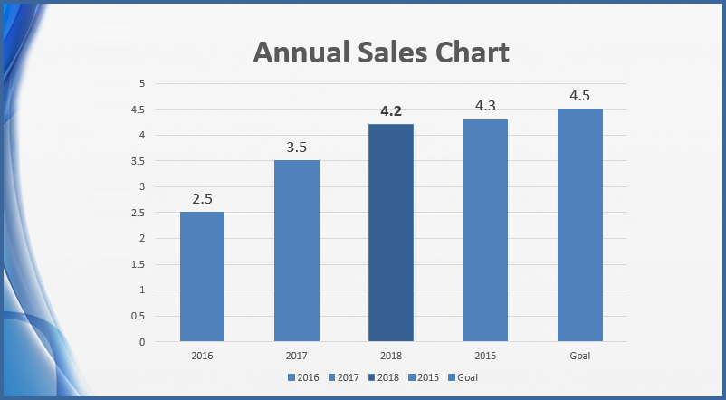

The PowerPoint can be susceptible to bad plots and graphs. This will be a continuing theme throughout the term. Each audience needs clear and concise messages from each visualization. Below is an example of a bad plot. When we circle back to what Silva mentioned with persuading the audience, there is a recognition that persuading the audience is a responsibility that should not be taken lightly. For example, the graph below shows too many lines in the background. In addition, the coloring of each graph is almost translucent, and the labels aren’t written out. Does March mean the whole month, or does it mean a subset of days? The legend is small while the red balls are labeled by yellow. These are all things that need to be considered when creating a visualization for a specific audience.

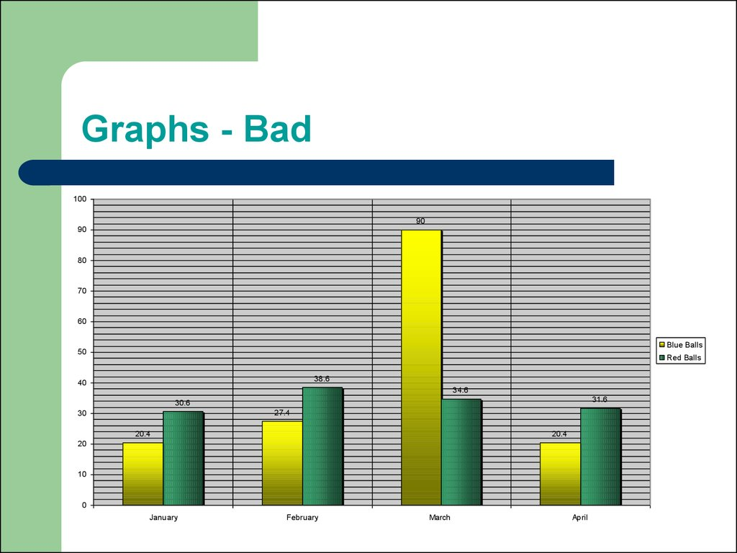

**Dashboard**

The Massachusetts dashboard is a tool that will be used by both the technical and non-technical audience. The method behind the dashboard is that data will be continuously updated to the dashboard and actionable insights will be derived from what the dashboard tells the Massachusetts Emergency Management Agency. The goal of the dashboard is to be able to be useful for both the technical and non-technical audiences. An example of the non-technical audience would be news stations or perhaps the local town officials. There is guidance on how to go about creating a dashboard of value: “1) Be clear about what you're trying to achieve – your board’s purpose will inform its design. 2) Only include what’s important – everything should support your board’s intent. 3) Use size and position to show hierarchy – make it clear to the viewer what’s most important. 4) Give your numbers context – help your viewers know if a number’s good or bad. 5) Group your related metrics – make your metrics easy to find. 6) Be consistent – using the same visualizations and layouts makes comparing easier. 7) Use clear labels for your audience – keep them short and self-explanatory. 8) Round your numbers – too much detail could make minor changes seem major. 9) Keep evolving your dashboards – check that your dashboard is encouraging the right behavior.” (Geckoboard, 2021).

The dashboard follows much of what Geckoboard mentioned in their bullet points. For dashboard is clearly about performance management and within the context of this final project-it is to update the board about what is going on with the storm. From the audience perspective, the dashboard needs to make sure only the important things are shown and for example, the storm dashboard might record the amount of precipitation or the percentage of homes without power. Number 3 and 4 from Geckoboard are tied together because 3 mentions what is important and 4 mentions context of figures. This is most apparent in the top 3 boxes of this dashboard below. We have “all teams: qtr to qtr, product team: yoy, the top 3 teams and the bottom 3 teams ytd” The dashboard is telling the audience what numbers are important and simultaneously telling the audience what numbers are good vs what numbers are bad. For example, the state dashboard might show a green 100% for homes with power in Wayland, Ma but it might show the audience a red 64% for homes with power in Edgartown, Ma.

Metrics for the dashboard below are consistent with one another. The whole left side of the dashboard are essentially line graphs. This is great because the audience can frame their analysis based on one type of chart. Moreover, the labels on each frame in the dashboard are consistent with each other. The lettering is the same size, font, and color. Again, we want to look at this from the perspective of the audience and make it easy for the audience to understand what the dashboard is telling us. Geckoboard mentions in number 8, that to keep things simple, you must round numbers to avoid sending the wrong messages. The dashboard below keeps up with that narrative to avoid any wrongful persuasion. With the state of Massachusetts in need of a dashboard that updates continuously because of the nature of extreme weather events, number 9 from Geckoboard mentions that the dashboard needs to evolve in the right direction.

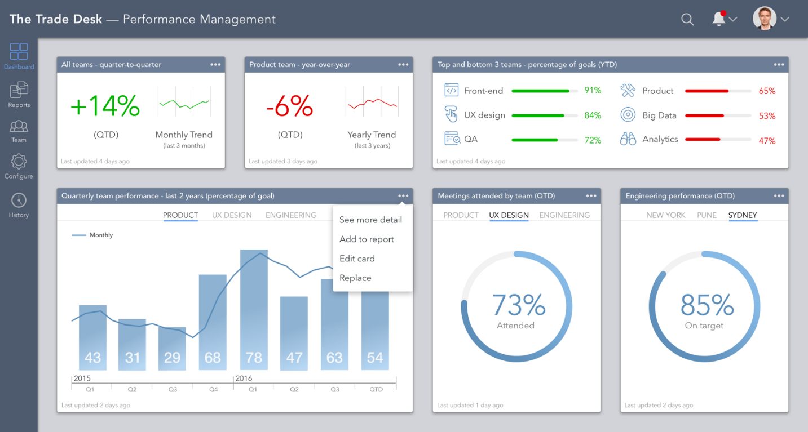

**Pamphlet/Web Page**

This is probably the best section to write about because I view this section of the milestone as your local town website. There is not a ton of information but what info is there, is important. From the viewpoint of the audience of a local town, the needs would be clear and concise language. The local townspeople would prefer simple words in whatever language is popular in that town. When reviewing the local town website, there needs to be a desire to update information as needed and just talk in simple terms. “An effective website design should fulfil its intended function by conveying its particular message whilst simultaneously engaging the visitor. Several factors such as consistency, colors, typography, imagery, simplicity, and functionality contribute to good website design.” (Marianne, 2021).

There is a bit of hesitation to include charts and graphs in a local town website. The reasoning is because of the non-technical audience and whether it is crucial for them to understand the data. “The non-techie is going to be less enamored by a bunch of statistics and random facts. Try to only include numbers if you can directly link them to something they need to know” (Quickbase, 2015). However, to be exhaustive, the graph below shows data in a manner that would be appropriate for local townspeople. We have labels correct and both axis’s the proper aesthetics. The graph is simple, and one would consider it appropriate for the local townspeople.

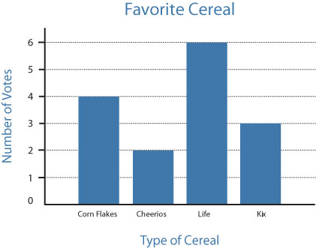

**Background**

Before we dive into data visualization strategy that discusses granularity and level of sophistication per audience. First, we need to recall each audience for each visualization. The power point audience is the audience that needs I would say the clearest and the most in-depth visualizations. The dashboard audience would be our analysts-the subset of individuals that are number’s people. The web page has always been viewed as the local town web page. This is source of local town information- an example might school cancellations or voting locations. It should be clear that the local townspeople should have the simplest visualizations out of the three groups.

**Power Point**

Data Points (2021) mentions that getting the data is the hardest and most time-consuming part of the visualization process. As the client of the state of Massachusetts, we have the responsibility to put together all of the relevant data needed by the state budget office. “Granular data is detailed data, or the lowest level that data can be in a target set.” (Techopedia, 2017). I think a great example of this would be needing to know where power lines are down in hard hit area instead of something similar in an area that missed the storm. In the power point, the guidelines must be in a great level of detail but the nuance here is that the visualization must clear and concise. An example of such a visualization is below:

“Use good-quality images that reinforce and complement your message. Ensure that your image maintains its impact and resolution when projected on a larger screen. Empty space on the slide will enhance readability.” (National Conference of State Legislatures, 2017). It just so happens that this image talks about the weather however, it does follow much of what the National Conference of State Legislatures talks about. These three graphs are good quality and there seems to be no misconceptions about what the data is telling us. Moreover, you can see that these graphs are probably best served to be a whole slide in the power point. The reasoning behind it is the next sentence “Empty space on the slide will enhance readability” (National Conference of State Legislatures, 2017).

Feedback is crucial to any iteration of work. In this context, I would like feedback to be immediate. An example would be when I am presenting this to the state budget office of Massachusetts. Q&A can be done after the meeting, but I would like the presentation to be a conversation. This way, especially in with the state, the conservation can help everyone involved. Also, there may be a frequently asked questions portion and the power point will have an email to send private feedback. That is the best strategy to overcome any technical or other challenges with the state budget office.

**Dashboard**



The above dashboard is what a good dashboard looks like. I have had much experience around dashboards, but I never created one. “What is relevant for companies is the level of granularity of their business data to be able to make appropriate decisions. If the data of all sales is added, it will be possible to analyse the sales in the last year of a specific product. Therefore, you can make queries and have a response from the data analysis in an agile way.” (Upicus, 2021). Upicus is right when it mentions the strategy of the dashboard. The level of granularity with dashboards is crucial. For example, you are a branch manager of a bank in Midtown, Manhattan. You use a dashboard to conduct your duties and you see your dashboard is stuck on national sales. What if your boss asks you to pull a report of net checking accounts your branch has opened over the past two weeks? Are you able to drill down to the past two weeks and then filter by branch?

These are the types of queries that someone at the states emergency management agency might have. Upicus also mentions to do their business in an agile way. Right now, the business is creating a dashboard that we can use to battle the storm. The dashboard needs to be up-to-date, and data must be uploaded fast. If the state can’t manage this storm in an agile way, there will be trouble. That is why the dashboard must be sophisticated enough to handle these data uploads. While the dashboard must be able to handle thousands of rows and columns of data, the display, and the way the dashboard tells the story needs to be simple. “These were dashboards built to the highest degree of technical proficiency and analytics prowess, but they failed to solve the problem that they were supposed to be solving for: Provide actionable information to the business.” (Warren, 2020). At the end of the day, that is what are here to do- provide actionable insights to the state.

Feedback is an interesting with the dashboard. The dashboard will have use during the storm, but the dashboard would need regular updates. Updates include fixing bugs, design changes, functionally fixes. These fixes take time and must go through their own processes. The state needs to understand the investment the dashboard requires when doing the updates/fixes. The dashboard will have a feedback button on the homepage where you can submit your feedback. This eliminates any ambiguities with either the technical or non-technical audience.

**Webpage**

The webpage is for the local towns people. This page should be advertised as the main source of every local town emergency. There is plenty of white space that helps with readability of the page. However, you were to scroll over the links some of them contain a lot of information. This webpage is great, but you don’t need that level of detail. Information like where to pay taxes or parking tickets should be readily available of course, but the webpage needs relevant information especially during a time of crisis.

The granularity of the webpage is clear with its big words and large icons. To most this may seem like a simple page, but the sophistication is there with the depth of its level of detail. The web page must be careful to not clutter the user that eventually inhibits them to use the site. The feedback should come from every source which would be the towns people and the employees of the state that use the site. The town website will have an email and phone number to send feedback. An example would be [*feedback@info.gov*](mailto:feedback@info.gov). Then those entities relay those items to us or their own web developers. The large portion of this audience would be non-technical folks. The technical stuff would come from the state or city, and you can go ask questions from these places. In contrast to a non-technical person looking up a particular formula, for example.

Implementation: Create the deliveries for each audience

**Background**

I have decided to analyze Dukes County in Massachusetts only. There are personal reasons why I chose to go with Dukes County. If you do not know, Dukes County is all of Martha’s Vineyard which means it is six towns: Edgartown, Oak Bluffs, Vineyard Haven, West Tisbury, Chilmark, and Aquinnah. Understanding how many storms occur or what is the cost of storm damage per period or per storm is important to an island because these variables affect the Vineyards economy. There are no major chains on the island so most of the island is local businesses that need every dollar they can get to drive revenue for their businesses.

**Power Point**

Power Point was submitted on brightspace,

**Dashboard**

Doing work on the Power Point brough to light some questions. Even though these questions could be answered with a little looking around in the data via the Power Point, it was much easier to find these answers with the dashboards. There are three dashboards created and they provide insights into different areas of interest. The first dashboard (Dashboard A) is about storm type vs count. The second dashboard (Dashboard B) is about storm type vs avg cost of property damage. The third dashboard (Dashboard C) is about month vs sum of property damage. Some of these dashboards might be similar to what was presented in the Power Point however, here we can manipulate the variables to try and understand functions between variables like storm type and cost of property damage. Moreover, we might be able to even forecast future storms and their costs!

**Dashboard A**



Here we have both 2015 and 2016 data for Dukes Co. We have wind as our top storm type and only two blizzards. We can look at one year at a time:



Or we can look at January and December storm events over the two year period:



**Note:** In the milestone submission, you can find these dashboards for your investigations.

We may find it useful to hone in on one month of a certain year, for example, February 2016:



This dashboard has a lot of value when trying to figure out the frequency of storms and their types. Moreover, you can see the send feedback button at the top in red. This will provide users the ability to send feedback to improve models and user experience. This theme will be continuous throughout these models.

**Dashboard B**



Dashboard B’s goal is to give us figures on what type of storm yields the most damage on average. I picked average because averages are the expected values for such an event. Dukes County now has an idea of what the cost will be on average and through this, the county can set aside emergency reserves for damages. In the figures below, our dashboards allow the user to edit the data shown via the table on the top-left or on the visualization with the *year* and *event_type* buttons.

1)

2)



The above figure shows the contrast between the damages of snow and the damages of a blizzard.

**Note:** also, remember on Dashboard B, the user is able to filter by year. This would be useful to look back on major storm events and their damages. Moreover, notice how we identify that 2016 had a blizzard and 2015 did not. We can see this by the total blizzard damages not changing between this figure below and figure 2 above.



**Dashboard C**



Dashboard C gives the user insights on when the bulk of the damages happen. Over the two year period, we can deduce that January has $30,000 in damages and from Dashboard B, we see that blizzard causes these damages. The dashboard has a regression line to forecast the next two periods. This dashboard even though it looks nice, it is not without error. Below we can see that the table does not include all the zeros and this error bleeds into the chart.



Below we can see that if we pick some of the missing months from above, it does not provide any context, but it would help create a more realistic regression line.

**Webpage**

The webpage for Martha’s Vineyard is a place where people can find information about what is going on with the county. The island’s websites homepage lists a number where you can call the county’s office, an email address to send feedback and a link to find the hub of storm information.

On the left side of the homepage, we see that there are two links. One link is to an emergency checklist. This is important because when there is a storm, incidents come up. For example, the power goes out for some hours or several days. As we see below, power being out might not be the only problem. Homes or cars might be damaged and since Edgartown is a harbor, there might be damage from boats coming ashore or simply being destroyed. The checklist is a great start for anybody who is looking to survive any storm.

After the checklist, the website presents that has a goal of visualizing the Mass and Dukes County storm data. This is extremely valuable to see most of the storm events are wind. Wind can knock over power lines and trees. If the storm is mixed with precipitation or lightning, it can make for a very deadly event.

This visualization is important for a few reasons. These two tables were generated with SQL. Since module 1, it has been considered to bring in SQL because of the power of tables like the two presented above. In the dashboard part, the event types were trimmed down. An example would be thunderstorm wind and strong wind being labeled as wind. In Dukes Co., wind is the largest number of storm events, taking spots 1 and 2. Whereas, in the rest of the state, thunderstorm wind is the number 1 event, and it is not close. These types of visualizations are great for the public because it takes a vast data set and breaks it down into an aesthetic table. Moreover, while there is nuance between high wind and strong wind, these nuances are not seen by the public. The public sees just wind. However, the local weathercasts still include such nuances in their analysis. The meteorologists might consider saying “stay inside, the wind will be too much”. If we recall our dashboard, where in Dukes County, it was shown that blizzards are the number one cause of property damage dollars and wind had zero. These type of analysis shows that the public needs to be prepare for weather events regardless if they will cause damage.

**References**

Silva. 2019. 3 Reasons why the PowerPoint is still effective. <https://umgtraining.com/2019/10/3-reasons-why-powerpoint-is-still-effective/>

Geckoboard. 2021. How to design and build a great dashboard. <https://www.geckoboard.com/best-practice/dashboard-design/>

Marianne. 2021. 9 PRINCIPLES OF GOOD WEB DESIGN. <https://www.feelingpeaky.com/9-principles-of-good-web-design/>

Quickbase. 2015. How to Explain Technical Information to Non-Techies. <https://www.quickbase.com/blog/how-to-explain-technical-information-to-non-techies>

Data Points. 2021. Page 138. <https://ebookcentral-proquest-com.ezproxy.snhu.edu/lib/snhu-ebooks/reader.action?docID=1158630>

Techopedia. 2017. Granular Data. <https://www.techopedia.com/definition/31722/granular-data#:~:text=Explains%20Granular%20Data-,What%20Does%20Granular%20Data%20Mean%3F,oriented%20a%20single%20field%20is>.

National Conference of State Legislatures. 2017. Tips for Making Effective PowerPoint Presentations. <https://www.ncsl.org/legislators-staff/legislative-staff/legislative-staff-coordinating-committee/tips-for-making-effective-powerpoint-presentations.aspx>

Upicus. 2021. The relevance of data granularity in business. <https://www.upicus.com/in/the-relevance-of-data-granularity-in-business/>

Cameron Warren. 2020. 3 Rules For Dashboards People Actually Look At. <https://towardsdatascience.com/3-rules-for-dashboards-people-actually-look-at-7d7c60fa3353>